Josiah Burchard

Vladimir Gerogieve

CS 480, Dr. Liu, 12/7/16

Socket Lab 2

Testing client/server locally

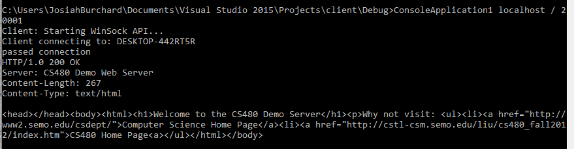

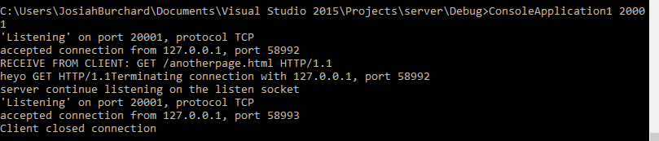

Testing server with web browser

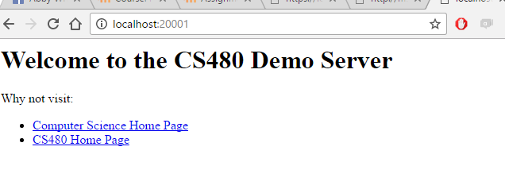

Testing client with standard web servers

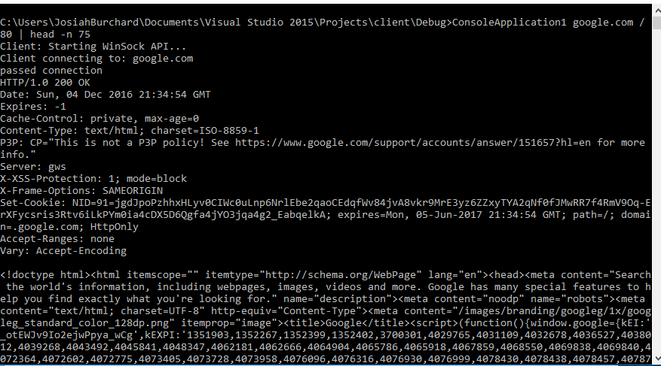

Testing client/server on different machines

